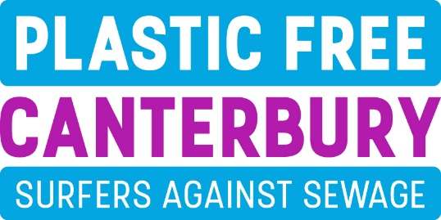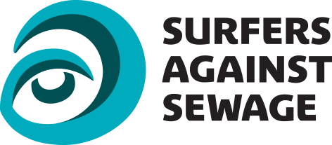

Plastic Free Canterbury have teamed up with Surfers Against Sewage with the aim of reducing single use plastics in our city and the surrounding villages. Our goal is to achieve Plastic Free Accreditation for our area.
The Covid pandemic has changed many parts of our everyday lives and has raised issues when it comes to all sorts of environmental matters. In partnership with local businesses and community organisations we want to find out the barriers to change and make efforts towards creating a better environment.
We would be grateful if you could spare a few minutes to complete the following survey. Too much plastic ends up in our seas, rivers and landscapes, we want to understand how single use plastics are used in our community and what can be done to mitigate the damage they inflict.

Business name and contact: ___________________________________________

How many people are employed within your business? _______

Please tick any single use products or more sustainable alternatives that your organisation use.

Single Use Plastic Problem More Sustainable Alternative

- Single use bottle reusable bottle - fill up as you go
- Coffee cup / lid reusable cup - great marketing tool
- Cutlery wooden / bamboo / reusable metal alternatives
- Straw/stirrer wooden / reusable metal alternatives
- Takeaway food packaging paper / card
- Plastic bags mesh bag, backpack, tote bags - great marketing tool
- Cotton buds organic variety – 100% biodegradable
- Disposable razors electric, reusable, grow a beard!
- Toothbrushes bamboo variety
- Plastic glasses / cups reusable glass, metal or plastic
- Sauce sachet glass bottle / ramekin / reusable plastic
- Balloon flyers / postcards / recycled Frisbees / sustainable wooden yoyo / cardboard badges etc

- Other; please list …………………………………….

Do you also sell any of the above single use plastics or more sustainable alternatives?

Yes No
If so, which ones? ...............................................................................................................................................
……………………………………………………………………………………………………………………………..
Do you encourage or offer a discount to customers who bring their own cup / bag / container?
Yes No

Would you support a deposit / return scheme for recyclable plastics, where a small deposit is paid each time you purchase plastic recyclables and is returned each time you recycle?

Yes No

Do you sell, give away or let balloons off during events?

Yes No

Were you aware there is a helium balloon release ban on Canterbury City Council land and events?

Yes No

What factors make it difficult for your business to adopt the use of more sustainable products?
……………………………………………………………………………………………………………………………..
…………………………………………………………………………………………………………………………….............................................................................................................................................................................

Please tell us about your business’ use of plastics and what you may have done so far to decrease their use and increase recycling (continue overleaf if necessary).
……………………………………………………………………………………………………………………………..
…………………………………………………………………………………………………………………………….............................................................................................................................................................................
Are you or others within your business concerned about plastic / packaging on the things you sell and use?
Yes No

Do your suppliers offer more sustainable plastic free alternatives?

Yes No
Would you consider putting pressure on your supplier or even changing supplier?

Yes No
Please provide any comments ............................................................................................................................
Does your business actively encourage recycling by providing guidance and appropriate bins?

Yes No

Have you heard of the refill scheme, where members of the public can refill reusable water bottles in various venues around Canterbury?

Yes No

If you have tap water available, would you be interested in joining the Refill scheme?

Yes No
Please provide any comments: .......................................................................................................................

Do you feel that the pandemic gives your business and the community as a whole an opportunity to rethink how it views the environment and the more sustainable use of limited resources?

Yes No
Do you encourage and promote alternatives to single-use plastics? Yes No

Please tell us how Newsletter Social media In person Speakers
Plastic Free Canterbury Facebook page. Other ………………………………………………..

Would you like us to help you promote the idea of avoiding single-use plastics?
Please tell us how Film Literature Speaker Other ……………………

Which single use plastics have you already phased out and which are you able to commit to phasing out within your business?
…………………………………………………………………………………………………………………………………………………………………………………………………………………………………………………………
……………………………………………………………………………………………………………………………

If you’re able to get involved would you be happy to feature in our literature and online presence to help spread the word?

Yes No
Please provide your email address: ................................................................................................

Thank you for completing our survey

Please follow us on our Facebook page – Plastic Free Canterbury – and tell your friends about us.

