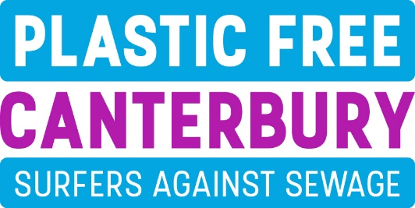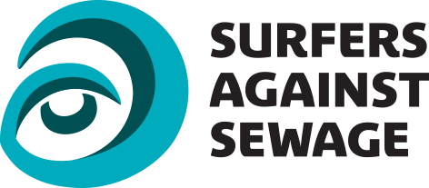

Plastic Free Canterbury have teamed up with Surfers Against Sewage with the aim of reducing single use plastics in our city and the surrounding villages. Our goal is to achieve Plastic Free Accreditation for our area.
The Covid pandemic has changed many parts of our everyday lives and has raised issues when it comes to all sorts of environmental matters. In partnership with local businesses and community organisations we want to find out the barriers to change and make efforts towards creating a better environment.
We would be grateful if you could spare a few minutes to complete the following survey. Too much plastic ends up in our seas, rivers and landscapes, we want to understand how single use plastics are used in our community and what can be done to mitigate the damage they inflict.

Name of School and contact: ___________________________________________

How many pupils are there in your school? _______ and how many staff? _______

Please tick any single use products or more sustainable alternatives that your school uses.

The Plastic Problem The More Sustainable Alternative

- Single use bottle reusable bottle - fill up as you go
- Coffee cup / lid reusable cup - great marketing tool
- Cutlery wooden / bamboo / reusable metal alternatives
- Straw/stirrer wooden / reusable metal alternatives
- Takeaway food packaging paper / card
- Plastic bags mesh bag, backpack, tote bags - great marketing tool
- Cotton buds organic variety – 100% biodegradable
- Disposable razors electric, reusable, grow a beard!
- Toothbrushes bamboo variety
- Plastic glasses / cups reusable glass, metal or plastic
- Sauce sachet glass bottle / ramekin / reusable plastic
- Balloon flyers / postcards / recycled Frisbees / sustainable wooden yoyo / cardboard badges etc

- Other; please list …………………………………….

Do you reuse any plastic bags that you may use?

Yes No
Do you encourage pupils and staff to bring their own cup / bag / containers?
Yes No

Do you ever give away balloons, or let balloons off during events?

Yes No

Are you aware there is a helium balloon release ban on Canterbury City Council land and events?

Yes No

Does your school take part in the Walkers Crisps / Terracycle crisp packet recycling scheme?

Yes No

Would you support a deposit / return scheme for recyclable plastics, where a small deposit is paid each time you purchase plastic recyclables and is returned each time you recycle?

Yes No

What factors make it difficult for your school to adopt the use of more sustainable products?
……………………………………………………………………………………………………………………………..
…………………………………………………………………………………………………………………………….............................................................................................................................................................................

Please tell us about your school’s use of plastics and what you may have done so far to decrease their use and increase recycling (continue overleaf if necessary).
……………………………………………………………………………………………………………………………..
…………………………………………………………………………………………………………………………….............................................................................................................................................................................

Have teachers at your school included sustainability in lessons as part of the National Curriculum requirements on Citizenship and / or Science?

Yes No

Would your school be interested in participating in any sponsored events that would encourage recycling and minimise use of single use plastics?

Yes No

Would your school be interested in a regional competition to design a mascot that would promote sustainability and reduce the use of single use plastics?

Yes No
Are you or other staff, pupils or parents concerned about plastic / packaging on the items you buy?
Yes No

Do your suppliers offer plastic free alternatives?

Yes No

Would you consider putting pressure on your supplier or even changing supplier?

Yes No
Please provide any comments ......................................................................................................................
Does your school actively encourage recycling by providing guidance and appropriate bins?

Yes No

Do you feel that the Covid pandemic gives our community a chance to rethink how it views the environment and the more sustainable use of limited resources?

Yes No

Do you encourage and promote alternatives to single-use plastics? Yes No

Please tell us how Newsletter Social media Lessons Assemblies
Plastic Free Canterbury Facebook page. Other ……………………..

Would you like us to help you promote the idea of avoiding single-use plastics?
Please tell us how Film Lesson plans Speaker Other ……………………

Are you able to commit to phasing out any single use plastics within your school?

Yes No

Which single use plastics have you already phased out and which are you able to commit to phasing out within your school?
…………………………………………………………………………………………………………………………………………………………………………………………………………………………………………………………
……………………………………………………………………………………………………………………………

If you’re able to get involved would you be happy to feature in our literature and online presence to help spread the word?

Yes No
Please provide your email address: ................................................................................................
Thank you for completing our survey
Please follow us on our Facebook page – Plastic Free Canterbury – and tell your friends about us.

